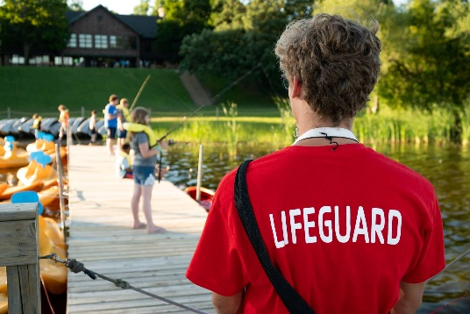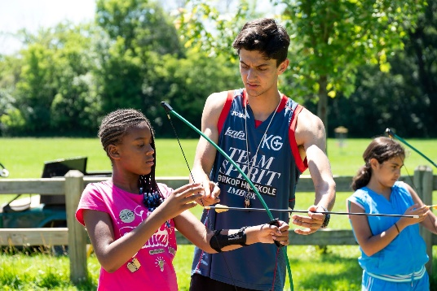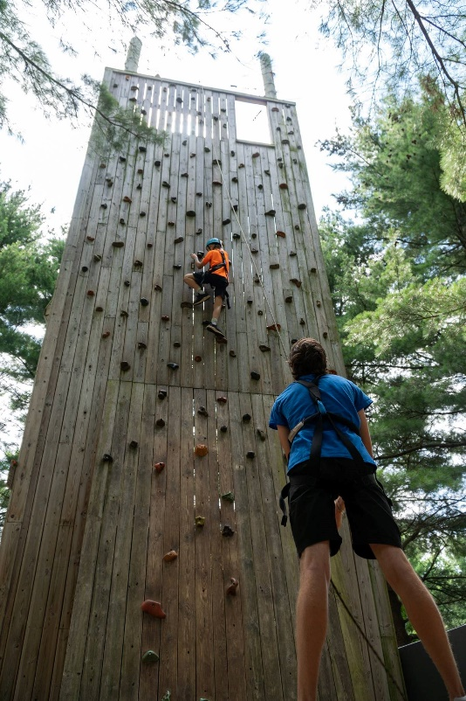

# 

# YMCA Camp Duncan Spring Positions

We’re seeking **7-8 interns and / or live on staff** who wish to continue making an impact on the lives of those around them in a unique, fun experience during the months of **February - June**. Camp Duncan is looking for people who understand the mission of the YMCA and will work to serve our guests and groups to the best of their abilities.

**Internship Includes:**

**If interested, contact:**

**Addie Smits**

**Hiring Specialist**

[**asmits@ymcachicago.org**](mailto:asmits@ymcachicago.org)

[**www.ymcachicago.org/duncan**](http://www.ymcachicago.org/duncan)

* Overall understanding of YMCA, as a nonprofit organization and overall camp environment
* Free trainings on Lifeguarding, First Aid/CPR, belay, teambuilding, leadership development, and more
* Room and board are provided
* Practical skills and application in a camp setting
* Internship Completion Bonus!

**Intern / Live On Staff Responsibilities:**

* Assist in the continued development of the Outdoor Education program.
* Facilitate weekly and weekend adventure programming.
* Ability to perform moderate physical activity, adapt to changing work conditions, work with diverse groups of people, gain organizational skills, and the ability to communicate effectively with customers.